
AIR FORCE SCHOOL JODHPUR
CURRICULUM DETAILS
CLASS – IX

S.No | SUBJECT | TERM 1 | TERM 2
1. | English | Kaveri Book  Ch-1. How I Taught My Grandmother to Read  P-1. Bharat Our Land  Ch-2. The Pot Maker  P-2. Gifts of Grace: Honouring Our Vocations  Ch-3. Winds of Change  P-3. Canvas of Soil  Ch-4. Vitamin-M  P-4. I Cannot Remember My Mother  Grammar  Sequence of Tenses in different contexts of communication  Modal Auxiliaries and their functions in expressing ability, obligation, permission, possibility and advice  Reported Speech in extended texts including – statements, questions, commands and requests  Conditional Clause – Type 1  Subject–Verb Concord  Determiners  Clauses – Noun Clause, Relative Clause  Writing Section  Notice Writing  Informal Invitation  Letter to Editor and  Formal E-mail on a given issue for presenting views and suggestions  Factual Description  Magazine Article  Descriptive and Narrative Essay | Kaveri Book  Ch-5. The World of Limitless Possibilities  P-5. Nine Gold Medals  Ch-6. Twin Melodies  P-6. A Friend Found in Music  Ch-7. Carrier Of Words  P-7. Words  Ch-8. Follow That Dream  P-8. Believe in Yourself  Grammar  Sequence of Tenses in different contexts of communication  Modal Auxiliaries and their functions in expressing ability, obligation, permission, possibility and advice  Reported Speech in extended texts including – statements, questions, commands and requests  Conditional Clause – Type 1  Subject–Verb Concord  Determiners  Clauses – Noun Clause, Relative Clause  Writing Section  Notice Writing  Informal Invitation  Letter to Editor and  Formal E-mail on a given issue for presenting views and suggestions  Factual Description  Magazine Article  Descriptive and Narrative Essay
2. | Hindi | 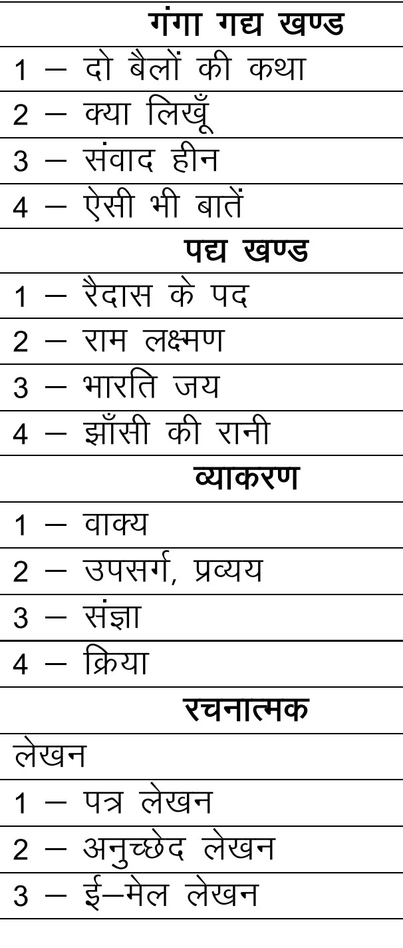 | 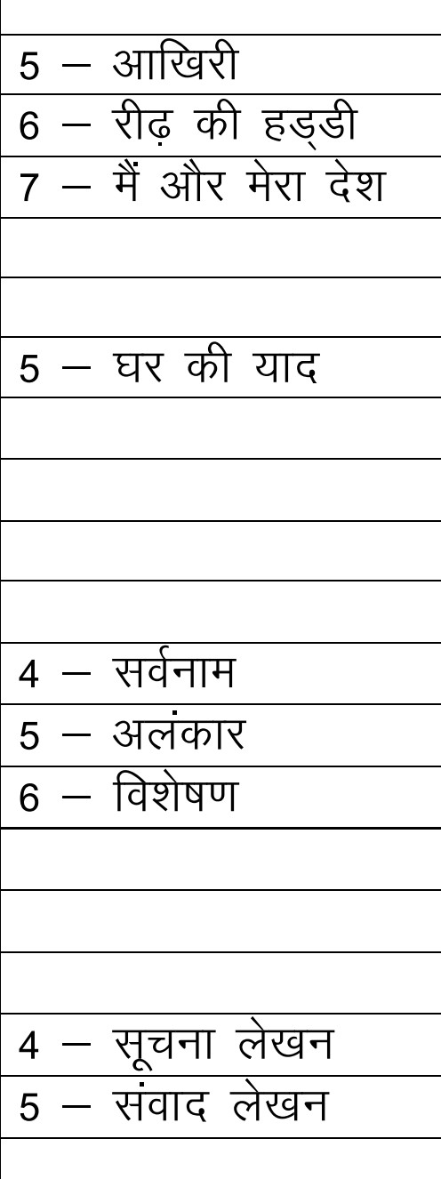
3. | Mathematics | Ganita Manjari Part–1  - Orienting Yourself: The Use of Coordinates  - Introduction to Linear Polynomials  - The World of Numbers  - Exploring Algebraic Identities  - I’m Up and Down, and Round and Round  - Measuring Space: Perimeter and Area  - The Mathematics of Maybe (Probability)  - Predicting What Comes Next (Sequences & Progressions) | Ganita Manjari Part–1  And  Ganita Manjari – Part 2  - Introduction to Euclid’s Geometry: Axioms and Postulates  - Lines and Angles  - Triangles: Congruence Theorems  - Quadrilaterals (4-gons)  - Circles  - Linear Equations in Two Variables  - Statistics  Whole course according to CBSE Norms
4. | Science | (BIOLOGY)  CH.2 CELL STRUCTURE AND FUNCTION  CH.3 TISSUE IN ACTION  PHYSICS  CH. 4 DESCRIBE MOTION AROUND US  CH.6 HOW FORCE AFFECT TO MOTION  CHEMISTRY  Ch-5. Exploring Mixtures and their separation  Ch-8. Journey Inside the atom | CH.11 REPRODUCTION HOW LIFE COUNTINUE  CH 12 PATTERNS IN LIFE: DIVERSITY AND CLASSIFICATION  CH. 7 WORK ENERGY AND SIMPLE MACHINES  CH.10 SOUND WAVES  Ch-9. Atomic foundations of matter  Ch-13. Earth as a system: Energy,Matter,and Life
5. | Social Science | Social Science (Part-1)  Ch-1. Understanding Social Science  Ch-2. Shaping of the Earth’s Surface  Ch-3. Atmosphere and Climate  Ch-4. Beginnings of civilisation  Ch-6. Democracy  Ch-8. Building blocks in Economics  Social Science (Part-2)  Ch-1. Oceans and Life  Ch-2. Life on Earth | Social Science (Part-1)  Ch-1. Understanding Social Science  Ch-2. Shaping of the Earth’s Surface  Ch-3. Atmosphere and Climate  Ch-4. Beginnings of civilisation  Ch-5. Society (upto 1000CE)  Ch-6. Democracy  Ch-7. Elections  Ch-8. Building Blocks in Economics  Ch-9. The Price Puzzle:What Drives the Market  Social Science (Part-2)  Ch-1. Oceans and Life  Ch-2. Life on Earth  Ch-3. Building a Resilient India(1000-1700 CE)  Ch-4. India and the World-I(1900 BCE-1200 CE)  Ch-5. Authority  Ch-6. From Ideas to Startups  Ch-7. Smart Ways to Manage Your Finances
6. | Information Technology | Part A  Unit 1: Communication Skills-I  Unit 2: Self-management Skills-I  Unit 3: Information and Communication Technology Skills-I  Part B  Unit 1: Introduction to IT- ITeS industry  Unit 2: Data Entry & Keyboarding Skills | Part A  Unit 4: Entrepreneurial Skills-I  Unit 5: Green Skills-I  Part B  Unit 3: Digital Documentation  Unit 4: Electronic Spreadsheet  Unit 5: Digital Presentation

